Name of Laboratory: Basic Electrical Engineering Lab

|  |  |
| --- | --- |
| Lab Subject Code | : EEE101L |
| Name of School | : SELECT |
|  |  |

**EARTH ELECTRODE RESISTANCE MEASUREMENT**

**Ex. No. : 9** **Date** **: 20/12/2021**

AIM

1. To get familiar with the working of an earth-tester.
2. To measure the Earth resistance and

Apparatus Required

|  |  |  |  |  |
| --- | --- | --- | --- | --- |
| **S. No.** | **Description** | **Range** | **Type** | **Quantity** |
|  |  |  |  |  |
| 1 | Hand driven Earth Tester | (1–100 )Ohms | AC | 1 |
|  |  |  |  |  |
| 2 | Digital Earth Tester | 3 ½ | Digital | 1 |
|  |  |  |  |  |
| 3 | Spikes | - | - | 4 |
|  |  |  |  |  |
| 4 | Hammer | - | - | 1 |
|  |  |  |  |  |
| 5 | Wire stripper | - | - | 1 |
|  |  |  |  |  |
| 6 | Connecting Wires | -- | -- | As Req. |
|  |  |  |  |  |

**Operating principle**

The principle used in measuring the earth resistance is based on simple ohms law. 4 electrodes A, B, C, D are buried in the earth, the resistance of which is to be tested at the distance of 20m from each other electrodes is shown in the figure.

A.C. signal is applied to electrodes A and B and the voltage developed across B and C due to flow of current through the earth is measured by ammeter M. if current is constant, the voltage measured will be directly proportional to the earth resistance.

**Principle of measurement**

To find out resistance of earth connection, the 3 terminal method is to be used.

A current is passed through the EARTH PLATE to an auxiliary electrode A in the earth at a distance away from the earth plate.

A second auxiliary electrode B is inserted between earth Plate and A, the potential difference V between E and B is measured for a given current I, so that the resistance of earth connection is V/I. the placing of the auxiliary electrodes is however important. Following is the curve which gives a plot of distance B from E verses measured resistance.

When earthing resistance is low, the spacing between the earth plate and the auxiliary electrode may be 20 to 30m. The exact value can be decided by actual experiment.

Name of Laboratory: Basic Electrical Engineering Lab

|  |  |
| --- | --- |
| Lab Subject Code | : EEE1003 |
| Name of School | : SELECT |
|  |  |

**How to operate the instrument**

To operate the instrument, first turn the range selection switch to 10Ω position. The digital display reads zero. Connect the test leads to the four terminals as per procedure for testing the given earth electrode. Press the TEST switch the LCD display will indicate the resistance. if “LO BAT indication appears on the upper side of the display while pressing the test switch, it indicates that the battery needs charging. After completing the testing, move the selector knob to OFF position.

**Procedure for testing**

The digital earth testes has four terminals marked as E1, P1, P2 and E2. It is suitable for measuring Earth resistance as well as earth resistivity.

**Measurement of the earth resistance**

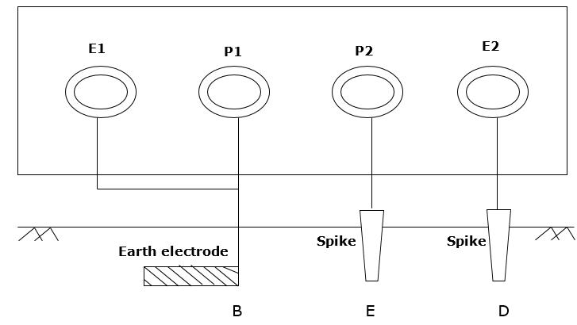

To measure earth resistance, it should be used as three terminal type. Terminals E1 and P1 is to be shorted and connected to the Earth Electrode whose resistance is to found. Connect as per figure and take the reading by pressing the TEST switch. Note down the reading displayed on the LCD display of the instrument.

Name of Laboratory: Basic Electrical Engineering Lab

|  |  |
| --- | --- |
| Lab Subject Code | : EEE1003 |
| Name of School | : SELECT |
|  |  |

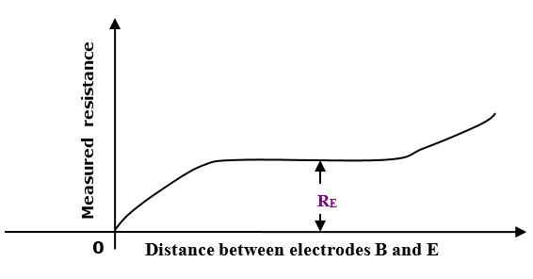



**Result**

**Reg. No: 21BDS0340 Name: Abhinav Dinesh Srivatsa Date: 20/12/2021**